Guía n° 2 – Connectors and arts – segundo trimestre

Curso: 1° medio. | Fecha: 22 de junio. | Calificación: | Puntaje Ideal: 37 pts. | Puntaje Obtenido:
Nombre del estudiante:

Objetivo de aprendizaje | Indicadores de Evaluación
OA 09: Demostrar comprensión de ideas generales e información explícita en textos adaptados y auténticos simples, en formato impreso o digital, acerca de temas variados.  OA 14: Escribir una variedad de textos, como cuentos, correos electrónicos, folletos, rimas, descripciones, biografías, instrucciones, artículos, cartas, resúmenes y diario personal. | - Leen textos literarios y no literarios apropiados a su nivel en forma independiente  - Escriben textos variados.
Instrucciones:
- Escribir nombre y apellido en casillero indicado.
- Esta guía es evaluada y deber ser entregada el día 24 de junio del 2021.
- Enviar al correo cami.profesoradeingles@gmail.com en formato PDF preferentemente o fotografías.
- El motivo del correo debe ser nombre y apellido del estudiante y curso, por ejemplo: José Díaz- 1° medio.

- Complete the sentences with the correct connector. (And- so- or- but- yet- for- nor). 1 pt. each one.

- I couldn’t sing yesterday, _____________ I was feeling sick.
- I was very happy for the award, ___________ I went to a party with friends.
- I won’t become famous singing in this town, _________ my fans need me.
- Do you play the violin _______ the guitar?
- He likes painting, ________ he prefers drawing.
- I will never learn to sing, _______ to dance.
- My manager ______ I get along very well.
- Write 3 examples using different connectors seen in the previous activity. (fanboys). 2 pts. Each one.
a) _________________________________________________________________
b) ________________________________________________________________
c) _________________________________________________________________
- Look at the pictures and express your preference using the connector “rather than”. 2 pts. each one.
a) ___________________________________
Playing video games / watching movies
b) ______________________________________
Movies / books
c) _______________________________________
Painting / dancing
- Answer the following questions. 1 point for using the correct structure, 1 point for saying the preference.

- Would you prefer a magazine or a newspaper? _______________________________________________________
- Would you prefer singing or dancing? _______________________________________________________
- Would you prefer reading or listening to a story? _____________________________________________________

- Write 6 art forms studied in classes or others. 1 pt. each one.
a) ___________________ d) _____________________
b) __________________ e) _____________________
c) __________________ f) _____________________

- Write opinions to the following art forms using linking words and expressions of opinions. 1 pt. for a linking word and 1 pt. for an expression of opinion.

- What´s your opinion about this controversial modern art?
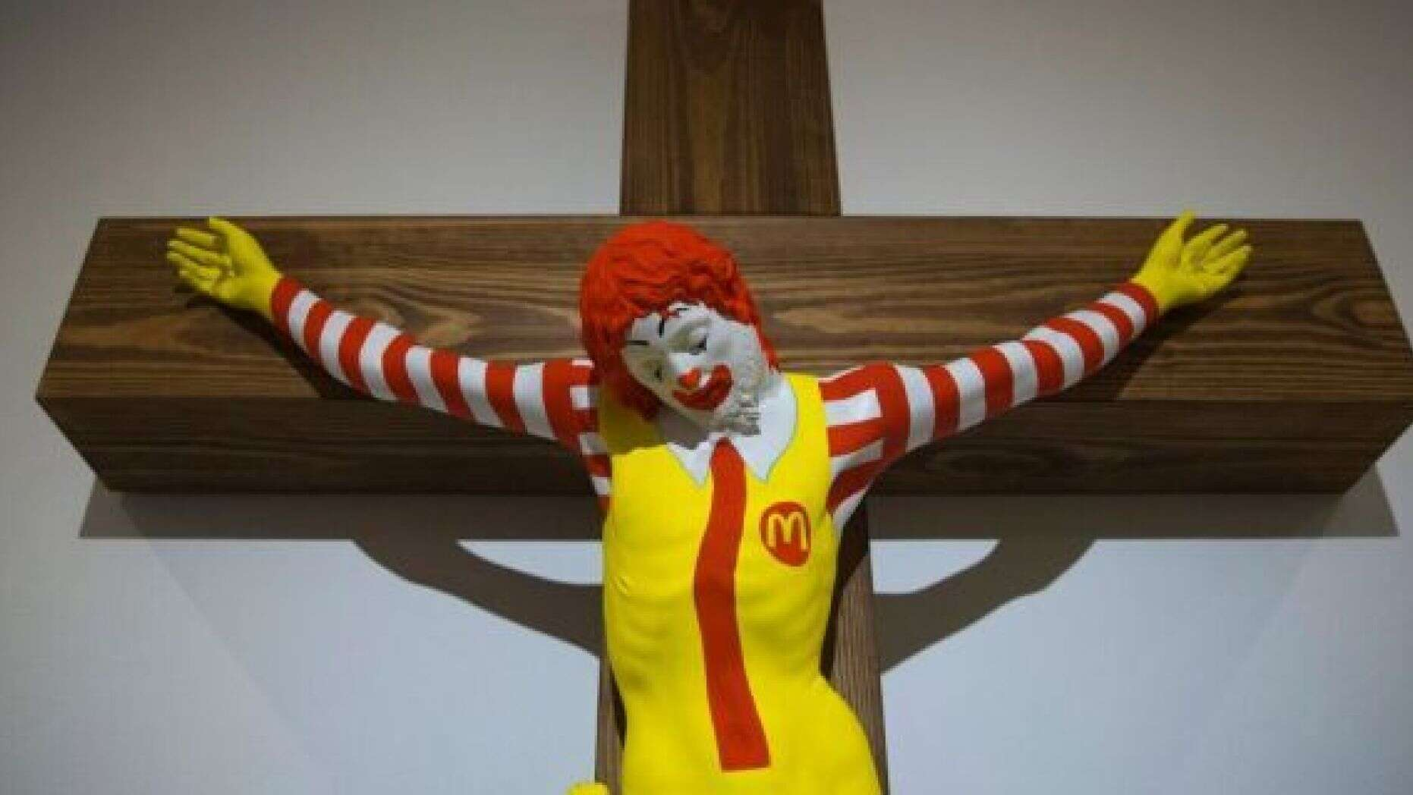 ___________________________________________________
- What’s your opinion about this famous work of modern art?
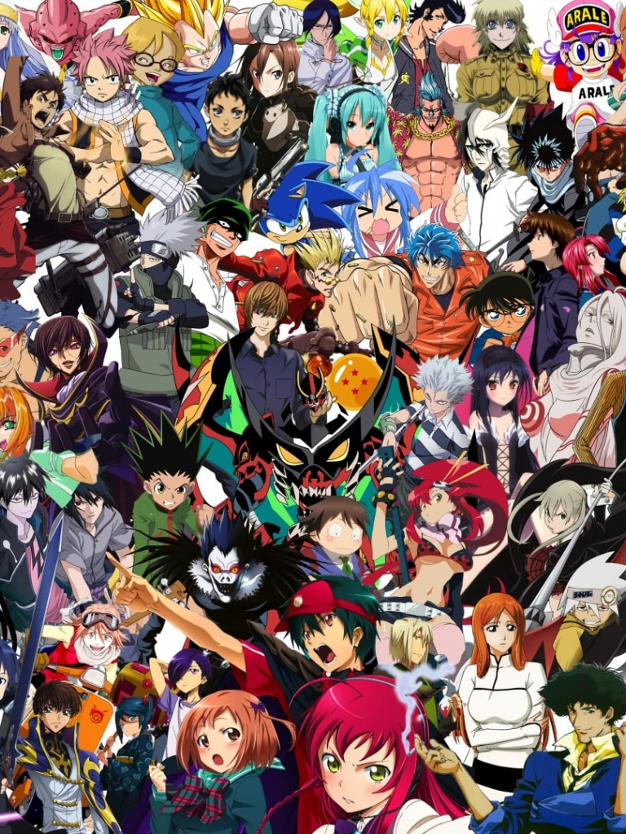 _______________________________________________________
- What’s your opinion about this unusual material used in art?
__________________________________________________

