Guía n° 2 – Use of language – segundo trimestre

Curso: 8° básico. | Fecha: 03 de agosto. | Calificación: | Puntaje Ideal: 44 pts. | Puntaje Obtenido:
Nombre del estudiante:

Objetivo de aprendizaje | Indicadores de Evaluación
OA 14: Escribir una variedad de textos breves, como cuentos, correos electrónicos, folletos, rimas, descripciones, biografías, instrucciones y resúmenes utilizando los pasos del proceso de escritura. | - Organizan la información en un diagrama o tabla.  - Usan varias herramientas de apoyo, como diccionario, software especial, textos de inglés.  - Escriben textos variados.
Instrucciones:
- Escribir nombre y apellido en casillero indicado.
- Esta guía es evaluada y deber ser entregada el día 05 de agosto del 2021.
- Enviar al correo cami.profesoradeingles@gmail.com en formato PDF preferentemente o fotografías.
- El motivo del correo debe ser nombre y apellido del estudiante y curso, por ejemplo: José Díaz- 8° básico.
- Se puede apoyar de la guía de estudio N°1 “comparatives and superlatives” subida a plataforma y de su texto de estudio página 42 Student’s Book.

- Complete the sentences using the correct form of the comparative. 2pts. Each one.
- USA’s constitution is _________________ (old) Chile’s Constitution.

- China is __________________(populated) Germany.

- Chile is _________________ (small) Argentina.

- USA is __________________ (big) China.

- Canada is _______________ (cold) than USA.
- Complete the sentences using the correct form of the superlative. 2pts. Each one.

- Chile is ________________________ (long) country in the world.

- China is _______________________ (populated) country is the world.

- Brazil is _______________________ (large) country in South America.

- China has _______________________ (old) formation according to history.

- Japan is _______________________ (expensive) country in the world.

- Choose the correct alternative to complete the sentences. 1pt. Each one.
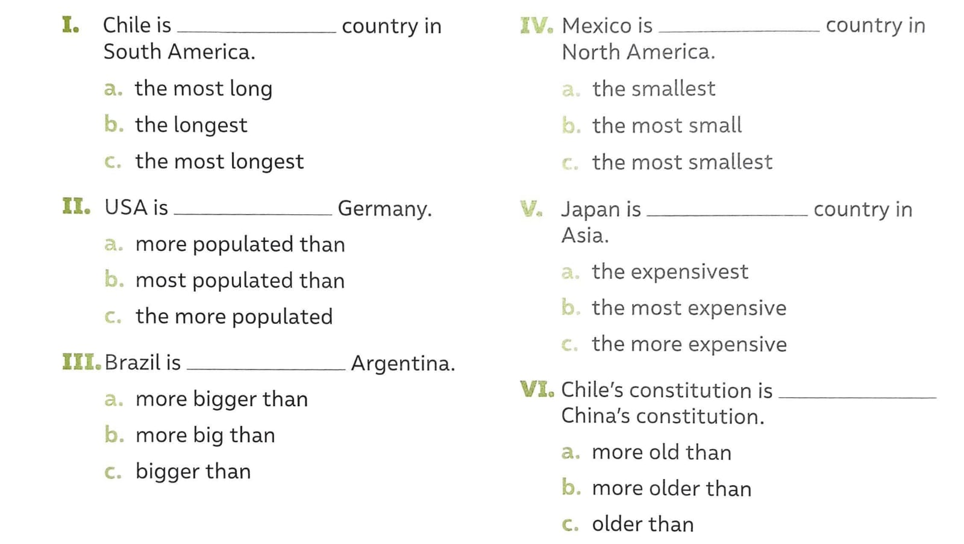

- Put an X in the right column. 1pt. each one.
Make | Do | Collocation
 |  | Noise
 |  | Breakfast
 |  | Homework
 |  | Karate
 |  | Fiends
 |  | The shopping
 |  | A phone call
 |  | laundry

- Complete the sentences with the correct form of the verb Make and Do. 1pt. Each one.

- My friend ____________ the laundry on weekends.

- I ____________ my bed before I leave home every morning.

- My dog always ___________ a mess in the living room.

- My sister and I ___________ yoga after school

- When I ___________ my homework I focus my attention on it.

- My grandma loves ______________ the gardening.

- The man who lives next door ___________a lot of noise every time he has a party.

- Rodrigo is very sociable, ____________ friends is not a problem for him.

- The doctor told my brother he has to __________ exercise.

- My dad had to ____________ a big effort to lift the sofa.

